The ability to link documents is available through the “Memos and Documents” Feature of The Concierge Assistant located within the QV icon on the main screen.
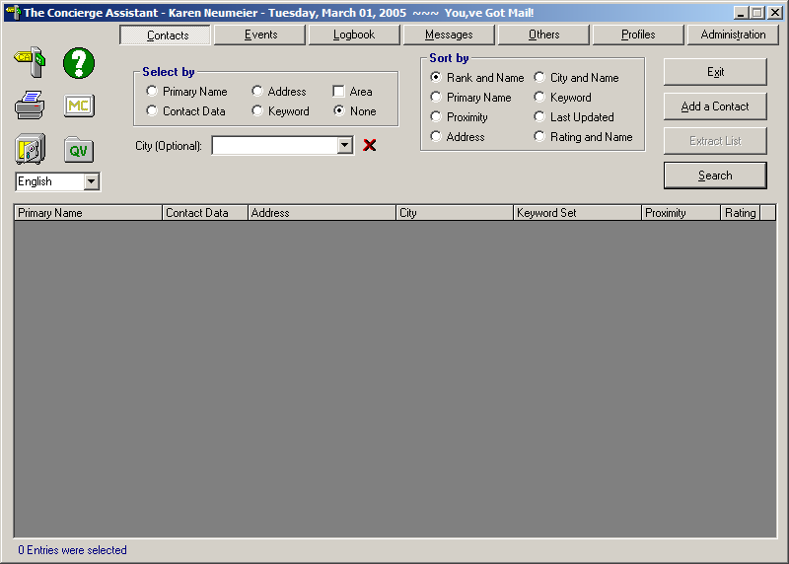

As an Administrator you will see theses options. Select “Document Links”.
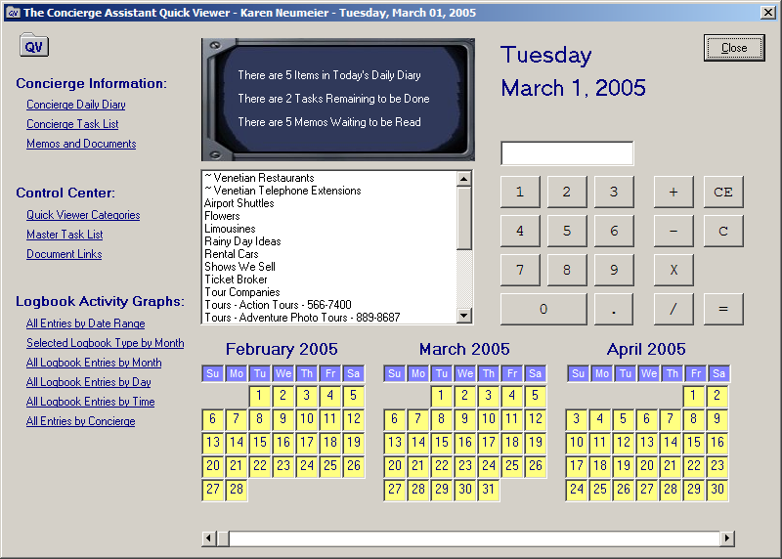

CA will present to you the “C” drive on your computer. As long as the document is in a “shared” folder that is accessible by every associate, each workstation using The Concierge Assistant will be able to view this document.
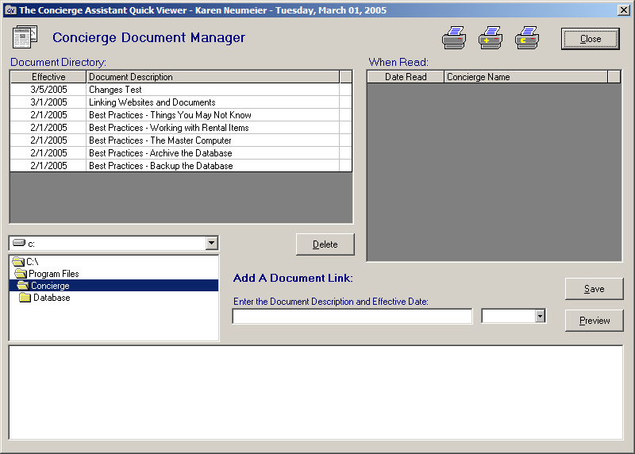

Find the file you desire to “link” to and highlight it. Enter the label you want to refer to it as, e.g. “Linking Websites and Documents” and then select the date you wish the document to begin appearing. Click on the Save Button. The name of your document will appear in the upper left corner. Close this window.
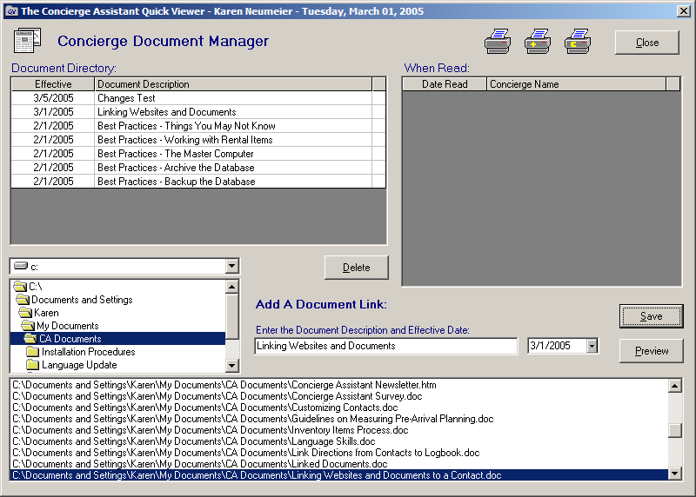
To check the link and to view what the other associates will be seeing, click on the “Memos and Documents” feature under the Concierge Information section.
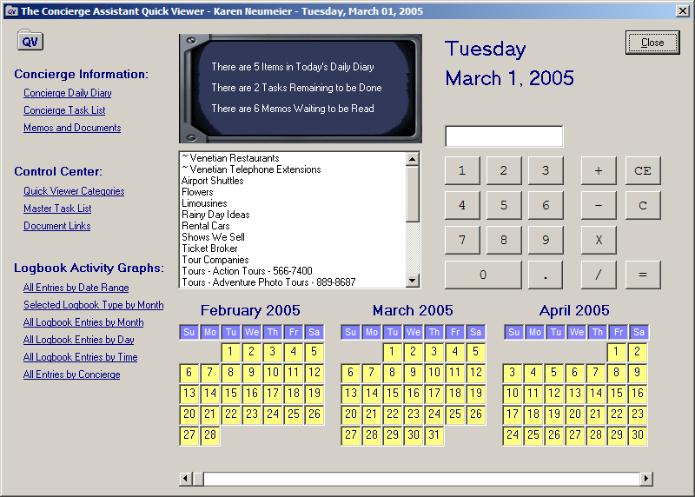

You will see the Document listed. When the Associates double click on the document …….

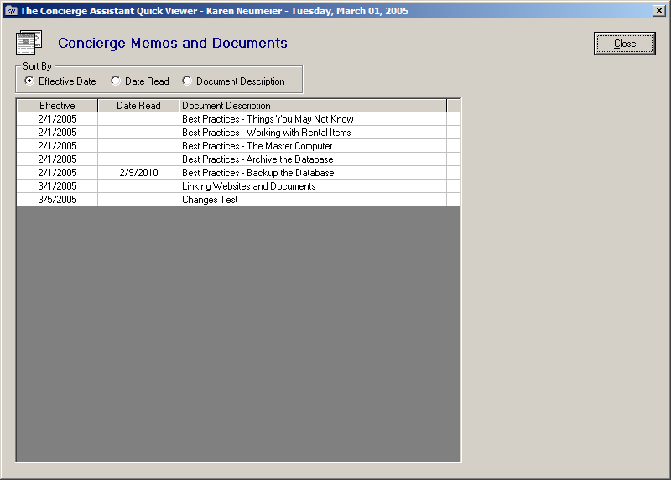

It will bring up the document that you have created the link to in the shared folder.

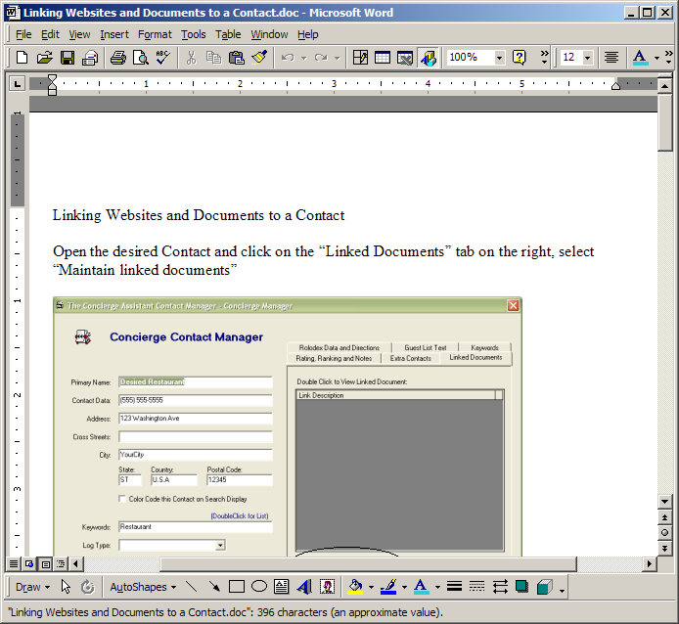

When the associates exit the document the following screen will appear. They will then have the ability to acknowledge that they have read and understood this document. When they have acknowledged this fact…
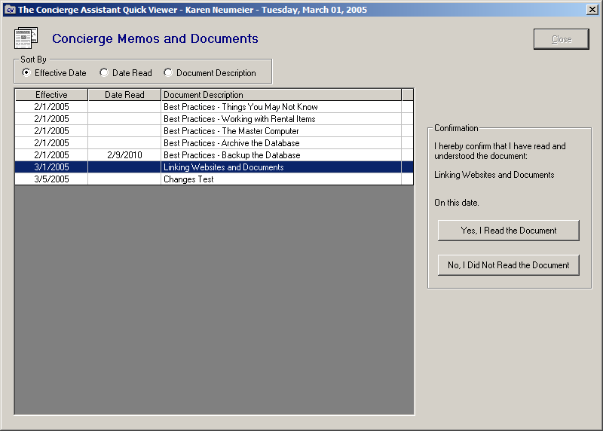
A date will appear next to their name.
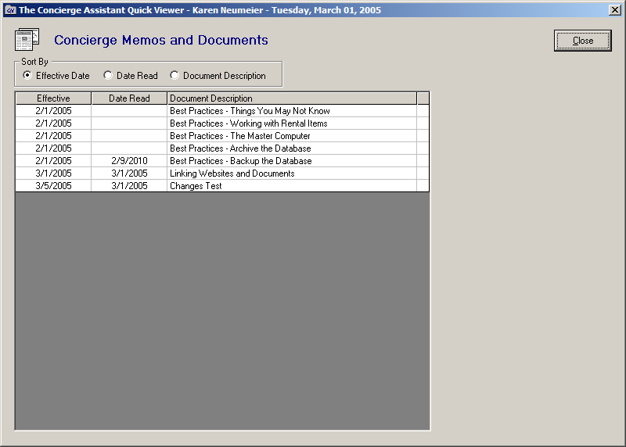

You also have the ability to see who has read or seen this document and who hasn’t by returning to the main QV screen and clicking on the Document Links again.

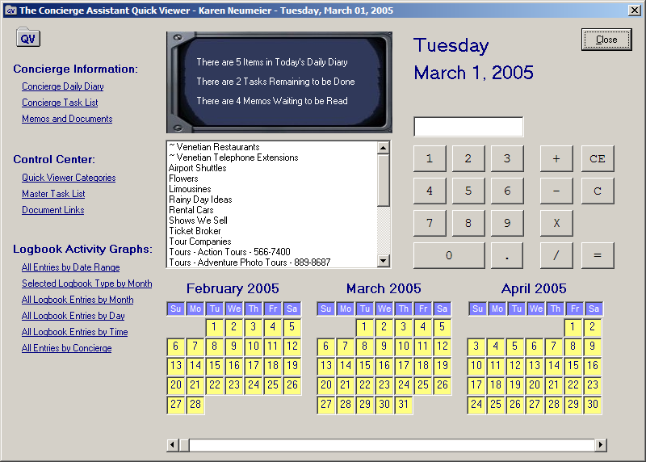

You may view the associates that have read a document by clicking on the name of the document you wish to track. The names of the associates signed up in CA under “Concierge Staff” will appear on the upper right with the dates read.

